**4. MANUAL – USER INTERFACE**

Here are the steps that the user should follow to run the Unity Application:

1. Download Unity Hub and Unity Editor

2. Open Unity Hub

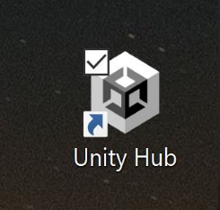

3. Click “Add project from disk” and chose “Pathfinding_Floodfill_Dijkstra_AStar” (Step 1)

4. Open Project (Step 2)

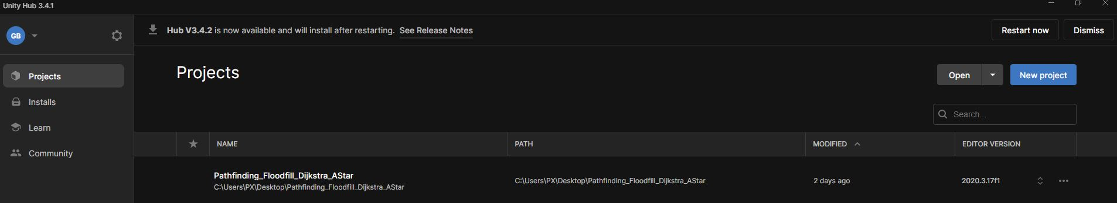

2

1

5. Click the “Play” button

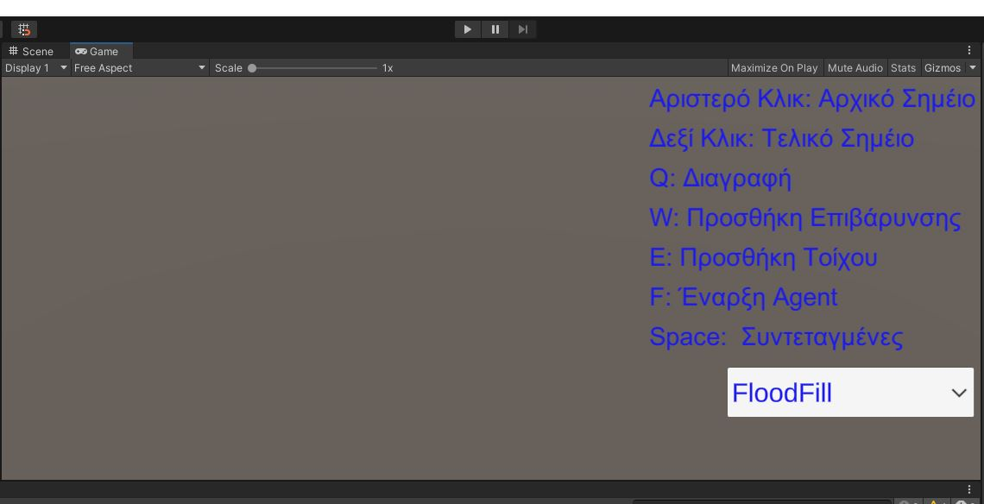

6. Select a Maze Navigation Algorithm from the Dropdown Menu

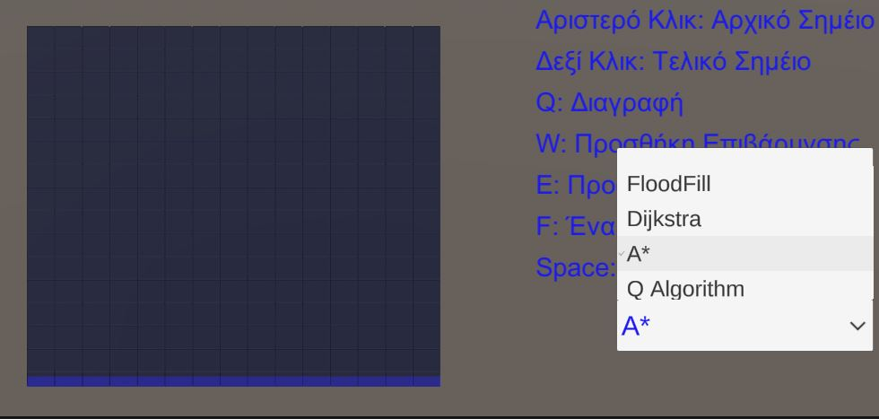

7. Set start and end point (Left Click and Right Click)

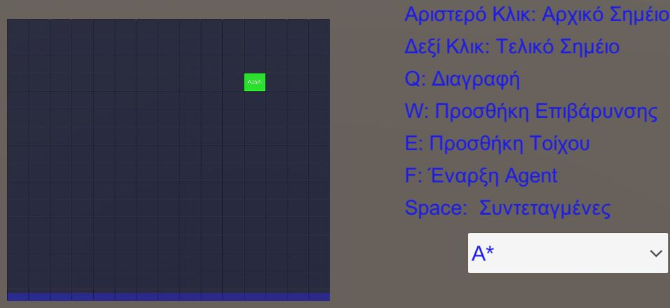

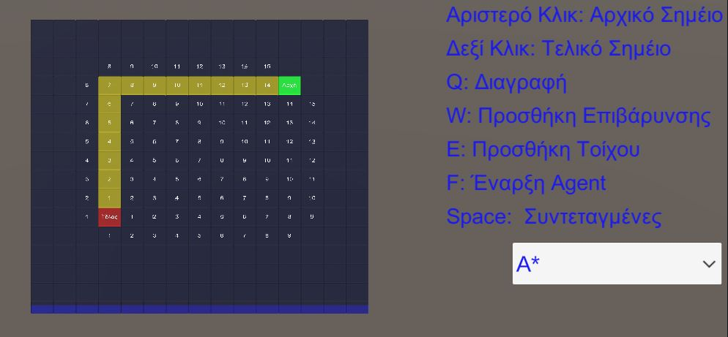

8. Set walls or costs (E and W buttons while hovering the mouse)

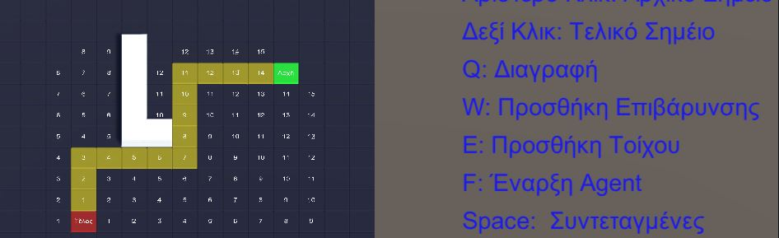

Cost

Walls

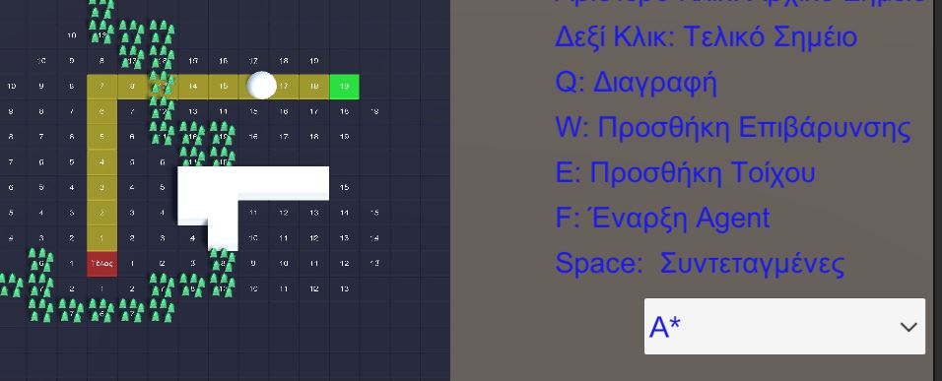

Cost

Walls

*By hitting the Q Button while hovering we can delete the walls and the costs we have added.

9. Hit the F Button so that the Agent starts moving.



